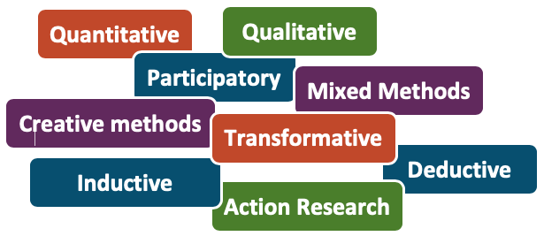
Beyond the YIF: Developing your Future Evaluation Plans
For example, pausing activities for young people to complete a questionnaire can be disruptive. A creative method, on the other hand, may function as an activity it itself, but the results may not be as comparable as the results from a questionnaire would be. These are the kind of things you need to consider when deciding your approach. The ‘Inspiring Impact’ website contains more useful information: inspiringimpact.org

Choosing your evaluation approach

Given the many different approaches to collecting data, it can be a challenge to know which to choose. Keep in mind that no single evaluation method can tell you the entire story. What makes a ‘good’ evaluation is dependent on what you want to learn, what others want to learn about you, and what you are doing the evaluation for. All methods have benefits and limitations that you must consider when deciding which approach to take.
Developing your evaluation plan
An evaluation plan is a useful tool for sketching out different elements of your evaluation. The template on the following pages can be used to support the creation of your plan. Below is a description of the different components that you will need to include, each correlating to a different area of the table on the next page.
- Evaluation question: before starting an evaluation you should always be clear on what you want to find out and what you plan to do with the findings. This should be captured in your evaluation question. This could include things such as: “what do the young people who attend our open access sessions think about their relationship with the youth workers?”; “if we hold sessions at the weekend will more girls show up?”; and “do the young people who attend our session experience improved self-esteem?”
- Object of measurement: this is the thing you are looking to measure. This could be an outcome, an indicator of quality, or a ‘mechanism of change’. Remember not to attempt to measure too much! In total we recommend that you select three to five objects of measurement, and each one should be placed on a new line in your evaluation plan. You should prioritise the things that are most important to your organisation, and make sure they are things that are within your influence.
- Data collection method: this is the method you will use to gather data. Where relevant, make sure you also note down the specific tool you are using. For example, if using a questionnaire, note whether this is a self-made survey or a validated tool (e.g. the Edinburgh Warwick Wellbeing Scale). If you’re using interviews or a focus group, the ‘tool’ would be the list of questions or topic guide being used.
- Who data is collected from: outline who you will be collecting data from, including the total number of expected participants (and the overall proportion if they are part of a larger group). If you are using a sampling strategy, refer to this here.
- Who collects data: this is the person (or people) responsible for the evaluation activity. This could be a job role and/or a named person.
- Ethical considerations: make a note of any ethical considerations. This includes things such as getting consent from young people, safeguarding, and data protection.
- Timing: outline how often and when data collection will take place. This could be the start and end a project, every 3 months, annually, etc. Include dates where possible.

This module provides guidance for developing an organisation-wide evaluation plan, and encourages you to reflect on what you’ve ‘learned about learning’ from the YIF.

Evaluation Planning Template
Organisation:
Project:
Monitoring processes  Make a note of how you record your ‘beneficiary’ data and ‘attendance’ data. |  |  |  |  | Demographic data  What beneficiary characteristics are of interest to you given your target group? Based on this, what demographic data will you collect? (e.g. ethnicity, gender, postcode, disability, age, sexual orientation)
1) Evaluation question | 2) Object of measurement |  | 3) Data collection method | 4) Who data is collected from |  | 5) Who collects data |  |  | 6) Ethical considerations |  | 7) Timing and frequency
1) Evaluation question | 2) Object of measurement |  | 3) Data collection method | 4) Who data is collected from |  | 5) Who collects data |  |  | 6) Ethical considerations |  | 7) Timing and frequency

