Formative Evaluation: Learning and Improving as You Go
Formative evaluation is intended to inform and improve your work as you go. In order to do this, you need to create an environment that supports learning, uses data to inform decisions, and encourages and rewards improvements. This module supports you to understand your existing culture and how it can be developed.

Evaluation ecosystems
An ‘evaluation ecosystem’ refers to the different evaluation roles that interact with each other within an organisation to make evaluation happen effectively. There are usually four roles in any evaluation exercise. Sometimes the same person embodies more than one of these roles, and in other settings different people take on each role.
- Planner: the planner sets the evaluative goals and priorities and selects appropriate methodologies.
- Participant: the participant takes part in surveys, interviews and focus groups, which generates programme data.
- Analyst: they review and analyse the data that comes out of an evaluation and make recommendations/decisions about what steps to take based on this information.
- Implementer: they carry out recommendations, making changes in operations or service delivery as a result of evaluation findings.
The boxes below explore how these roles interact to form an evaluation ecosystem, and how this ecosystem can either be balanced or broken.
Source: Camman, C. (2015). “Better Programme Evaluation”, www.camman-evaluation.com/blog/2015/11/25/better-program-evaluation-through-frontline-staff-engagement

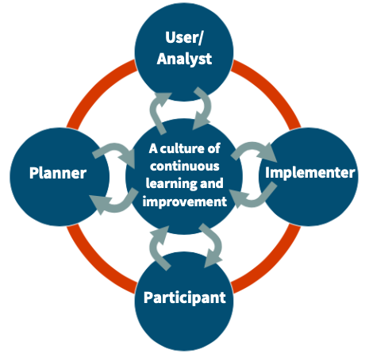
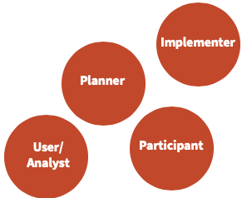
Balanced evaluation ecosystems
A balanced evaluation system is one where all roles are joined by a healthy communication pathway, resulting in a culture of continuous improvement where everyone has something to contribute and to gain. Characteristics include:
- Coordinated evaluation efforts: resulting in plans that
are feasible and relevant
- Sense of ownership and responsibility: people
understand how their contribution feeds into the
wider evaluation, so they are incentivized to do
their part well, leading to higher quality data.
- Areas to improve are identified: based
on evidence rather than ‘hunches’
- Evaluation is a worthwhile activity: and
therefore, is more likely to become embedded long term.

Broken evaluation ecosystems
A broken evaluation system occurs when the evaluation roles are siloed from one another and people don’t communicate. Characteristics include:
- Evaluation plans aren’t feasible or relevant: the planner, detached from the other roles, lacks the info needed to plan meaningful evaluation
- Little incentive to make changes to services: services evolve over time, but this isn’t informed by high quality data and evidence
- Data collected is sparse and low quality: when
people in the organisation don’t see any changes
happening as a result of data, they are less
likely to collect it carefully
- Confusion and frustration: about
what measurement’s for and
how to do it.
Managing risk
Evaluation can be complex, which can mean that staff feel daunted or threatened by it. Below are some techniques for managing this risk within your organisation.
- Use measured language: for example, you can refer to it a Learning Report rather than an Evaluation or an Impact Report
- Set SMART targets: you may want to aim for some small, quick wins at the start. You can then build from that as your team gets more comfortable with collecting and using evidence
- Have evaluation written into people’s job descriptions and discuss it openly in line management sessions and team meetings.

Using data to inform decisions and track progress
Used effectively, data can be fundamental in helping to improve your work. The report below supports you to turn data into knowledge, wisdom, and actionable insights. The report was produced by NPC and is entitled ‘Data with Destiny’.
www.thinknpc.org/wp-content/uploads/2018/07/Data-with-destiny_NPC-1.pdf

Assessing your existing evaluation ecosystem
By thinking about and making notes on the following questions, it can help you consider and assess your existing evaluation ecosystem.
To identify the roles in your ecosystem, think about the following:
- Who plans your evaluation?
- Who are your participants? (I.e. who do you collect data from?)
- Who sees and uses the data? Who then analyses and interprets it?
- Who’s in a position to implement evaluation findings & act on insights?
How do these people talk to each other?
- Does the planner consult the participants and user when choosing an evaluation methodology?
- How does the user share the evaluation findings and plan to act on them with the implementer?
- Are evaluation findings shared with the participants?
How balanced is your ecosystem?
- Are there communication links in your ecosystem that could be improved? Which links require improvement?
- Are there individuals who feel like they contribute more than they gain from evaluation? Who are they?
- Who gains the most from evaluation? Is there anyone who does not feel like they gain from evaluation?

Tips for nurturing your evaluation ecosystem
- Agree and become confident with your evaluation plan
- Tell everyone about your evaluation plan
- Get buy-in by involving people in the process (of both planning the evaluation and carrying it out)
- Demonstrate the value of evaluation
- Assign clear roles and responsibilities
- Recruit and train individuals with necessary the skills (or consider using external support)
- Think about incentives for staff to contribute to evaluation activity
- Make data collection and use as easy as possible
- Set up systems and processes for learning
- Tolerate mistakes and failure…
- If you face challenges in data collection, stick with it! You will get better
- Be aware of the possibility that your data may show no change or a negative change. Have a plan for dealing with unexpected results, and for changing for the better based on these results.

Evaluation Ecosystem Action Plan
This tool can be used for developing an action plan for strengthening your evaluation ecosystem.

How would you currently describe your evaluation culture? |  |  | How would you like to describe your evaluation culture?
 | What do they already do well? | What do they need to improve?  These can be things like confidence, incentives, guidance and support, time. |  | What can be done about it?  This can be things like training, reflective practice sessions, line management meetings about evaluation, investment in systems. | Timeline  When could this be done by? What key milestones will work towards this, and when will these take place?
Planner
Participant
Analyst
Implementer

