Asking Good Questions
What do young people think about what we do?

Are we achieving our aims?

Name of Author

XX/XX/XXXX

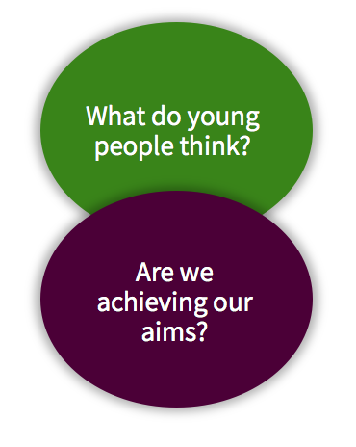
Questions 5 and 6 are about listening and responding to young people’s feedback and drawing together evidence that helps you to understand whether you are meeting your aims. These aims could be specific, pre-determined outcomes (like improved attendance at school or college), broader outcomes related to social and emotional development (including self-efficacy, teamwork and empathy), or ‘experiential’ goals, like young people accessing a safe space with their peers.

Question 5: What do young people think about what you do?
  - How frequently would it make sense to collect feedback, how, and from whom? How will you ensure that all young people have a voice?

  - Are there any particular challenges that you might face?

  - Can you suggest up to five feedback questions your organisation could ask?
  - Think back to your mechanisms of change on your theory of change.

  - How might the organisation respond to feedback from these questions in a way that would improve quality, delivery and young people’s experience?

Question 6: Are you achieving your aims?
  - What is/are the aim(s) of your work?
How were they were decided?

  - Are there pre-determined outcomes for your provision?
If so, what are they? If not, do you think this matters?

  - How might Question 6 be answered in a meaningful way for your organisation?

  - For you, what would make that approach meaningful?

